Readings:

* Multiple Table Processing: JOINS
  + chapter 7: “Advanced SQL” (Hoffer, Ramesh, & Topi) page 289- 298
  + chapter 6: “Queries: JOIN Operator” (Petkovic) from page 240 -255
* Multiple Table Processing: Subquery
  + chapter 6: “Queries: Correlated Subqueries” (Petkovic) from page 255 to the end of the chapter
  + chapter 7: “Advanced SQL” (Hoffer, Ramesh, & Topi) from page 289 -310

Homework assignment:

* Homework part A
  + Chapter 7(Hoffer, Ramesh, & Topi)
  + Problems and Exercises 1,2,3,4,5
* Homework part B

Use the “sample_DDL_script.sql” file from the blackboard to create a sample database named “sample”.  Use a second script file named “sample_insert_script.sql” to populate the database with sample data.  Both files can be downloaded from the class blackboard.

Using the database created, answer write the SQL statements for the following questions:

1. Return a list with dept_no and a count of employees in each department.
2. Return a list with dept_no and a count of employees in each department. Only show departments with greater than or equal to 2 employees
3. Find the highest employee number.
4. What is the difference between COUNT(*) and COUNT(column)? Write a SQL Example
5. Get the project_no that are done by more than 1 employee.

**Homework part A**

1.  
a) **SELECT** COURSEID, COURSENAME

**FROM** COURSE

**WHERE** COURSEID **LIKE** 'ISM%';

Venn Diagram :

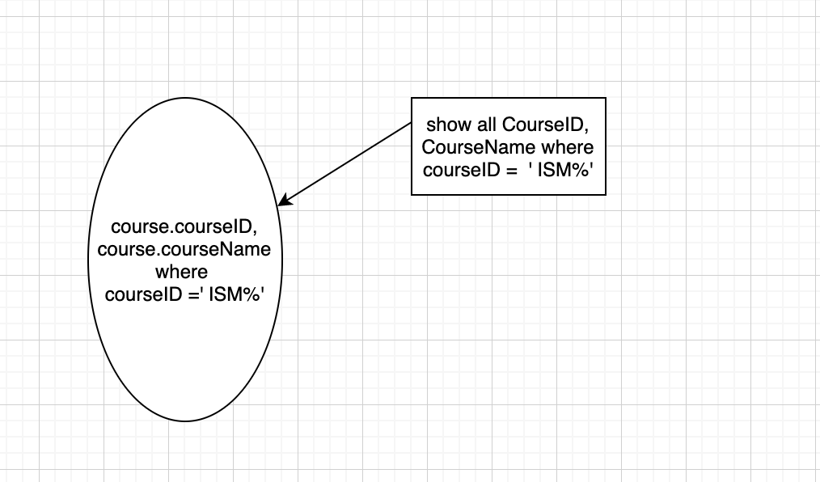

b)

**SELECT** FACULTYNAME, COURSE.COURSEID, COURSENAME

**FROM** FACULTY, COURSE, QUALIFIED

**WHERE** QUALIFIED.FACULTYID = 3467

**AND** FACULTY.FACULTYID= QUALIFIED.FACULTYID

**AND** COURSE.COURSEID=QUALIFIED.COURSEID;

Venn Diagram:

c)

**SELECT** s.STUDENTNAME, s.StudentID , s2.CourseID , r.sectionno, r.semester

**FROM** Student s , Faculty f , COURSE c , [SECTION] s2 , REGISTRATION r

**WHERE** S2.SectionNo = r.SectionNo

**AND** s.StudentID =r.StudentID

**AND** r.SectionNo = 2714

**AND** s2.Semester = 'I-2008'

**AND** r.Semester = 'I-2008'

**ORDER** **BY** StudentName;

Venn Diagram:

2)

**SELECT** F.FACULTYNAME , c.COURSENAME

**FROM** QUALIFIED q ,Faculty f , COURSE c

**WHERE** q.FacultyID = f.FacultyID

**AND** q.CourseID = c.CourseID

**AND** q.CourseID = 'ISM 3113';

3)

**SELECT** F.FACULTYNAME , c.COURSENAME

**FROM** QUALIFIED q ,Faculty f , COURSE c

**WHERE** q.FacultyID = f.FacultyID

**AND** q.CourseID = c.CourseID

**AND** q.CourseID = 'ISM 3113'

**AND** q.CourseID <> 'ISM 4930';

4)

a)

**SELECT** **COUNT**(**DISTINCT** STUDENTID) **AS** TOTALSTUDENTS

**FROM** REGISTRATION

**WHERE** SectionNo = 2714

**AND** Semester ='I-2008'

b)

**SELECT** **COUNT** (**DISTINCT** (StudentID)) **AS** TOTALSTUDENTS

**FROM** [SECTION], REGISTRATION

**WHERE** [SECTION].SectionNO = REGISTRATION.SectionNo

**AND** [SECTION].CourseID = 'ISM 3113'

**AND** [SECTION].Semester = 'I-2008';

5)

**Select** STUDENT.StudentID, STUDENT.StudentName **from**

STUDENT **Where** **NOT** **EXISTS**

(

**SELECT** * **FROM** REGISTRATION

**WHERE** REGISTRATION.StudentID = STUDENT.StudentID

**AND** REGISTRATION.Semester = 'I-2008')

**Homework part B**1. Return a list with dept_no and a count of employees in each department.

**select** e.dept_no , **count**(**DISTINCT** e.emp_no) **as** Employee_Count

**FROM** employee e , subdivision s

**WHERE** s.dept_no = e.dept_no

**group** **by** e.dept_no

2. Return a list with dept_no and a count of employees in each department. Only show departments with greater than or equal to 2 employees

**SELECT** s.dept_no **from** subdivision s

**WHERE** (**SELECT** **count**(**DISTINCT** e.emp_no )**as** employee_count **from** employee e **WHERE** s.dept_no = e.dept_no **group** **by** e.dept_no ) >= 2

**Another Method:**

**select** e.dept_no, **count**(*) **as** employee_count

**from** employee e

**group** **by** e.dept_no

**HAVING** **COUNT**(*) >= 2

**3 .** Find the highest employee number.

**select** **max**(emp_no) **as** Highest_EmployeeNumber

**FROM** employee

4. What is the difference between COUNT(*) and COUNT(column)? Write a SQL Example

**COUNT (*) EXAMPLE :**

**select** **count**(*) **from** employee

**TOTAL ROWS :**

**COUNT(Column) : EXAMPLE :**

**Count(*) : gives total count of the rows in a table**

**Count (distinct Column) : gives total count of unique values for that particular column in a table.**

5.

Get the project_no that are done by more than 1 employee.

**SELECT** project_no, **COUNT**(*) **as** employee_count

**FROM** works_on

**GROUP** **BY** project_no

**HAVING** **COUNT**(*)>1

